- Copyright for test papers and marking guides remains with West Australian Test Papers.
- The papers may only be reproduced within the purchasing school according to the advertised conditions of sale.
- Test papers must be withdrawn after use and stored securely in the school until Friday, December 2

HUMAN BIOLOGY

Unit 1 & 2

2016
MARKING KEY

Name: _______________________________________________________

Teacher: ___________________________________________________

TIME ALLOWED FOR THIS PAPER

Reading time before commencing work: Ten minutes
Working time for the paper: Three hours

MATERIALS REQUIRED/RECOMMENDED FOR THIS PAPER

To be provided by the supervisor:
- This Question/Answer Booklet
- Multiple Choice Answer Sheet

To be provided by the candidate:
- Standard items: Pens, pencils, eraser or correction fluid, ruler, highlighter, ruler.

- Special items: Calculators satisfying the conditions set by the Schools
Curriculum and standards authority for this subject.

IMPORTANT NOTE TO CANDIDATES

- No other items may be taken into the examination room. It is your responsibility to ensure that you do not have any unauthorised notes or other items of a non-personal nature in the examination room. If you have any unauthorised material with you, hand it to the supervisor before reading any further.

Structure of this paper

Section | Suggested working time | Number of questions available | Number of questions to be attempted | Marks | Percentage
SECTION ONE:  Multiple-choice | 40 minutes | 30 | All | 30 | 30
SECTION TWO:  Short answers | 100 minutes | 10 | All | 100 | 50
SECTION THREE:  Extended answers | 40 minutes | 3 | 2 | 40 | 20
 |  |  | Total marks | 170 | 100

Instructions to candidates

1. The rules for the conduct of Western Australian external examinations are detailed in the Year 12 Information Handbook 2016. Sitting this examination implies that you agree to abide by these rules.

2. Answer the questions according to the following instructions.

Section One: Answer all questions on the separate Multiple-choice Answer Sheet provided. For each question shade the box to indicate your answer. Use only a blue or black pen to shade the boxes. If you make a mistake, place a cross through that square, do not erase or use correction fluid, and shade your new answer. Marks will not be deducted for incorrect answers. No marks will be given if more than one answer is completed for any question.

Sections Two and Three: Write your answers in this Question/Answer Booklet.

3. You must be careful to confine your responses to the specific questions asked and to follow any instructions that are specific to a particular question.

4. Spare pages are included at the end of this booklet. They can be used for planning your responses and/or as additional space if required to continue an answer.
- Planning: If you use the spare pages for planning, indicate this clearly at the top of the page.
- Continuing an answer: If you need to use the space to continue an answer, indicate in the original answer space where the answer is continued, i.e. give the page number. Fill in the number of the question(s) that you are continuing to answer at the top of the page.

Section One: Multiple-choice 30% (30 Marks)

This section has 30 questions. Answer all questions on the separate Multiple-choice Answer Sheet provided. For each question shade the box to indicate your answer. Use only a blue or black pen to shade the boxes. If you make a mistake, place a cross through that square, do not erase or use correction fluid, and shade your new answer. Marks will not be deducted for incorrect answers. No marks will be given if more than one answer is completed for any question.

Suggested working time: 40 minutes.
____________________________________________________________________

- All cells in the human body contain the hereditary material which is isolated from the rest of the cell by

(a) cell membrane
(b) nuclear envelope
(c) nucleoplasm
(d) nucleolus

- What kind of inheritance is represented by the following pedigree chart?
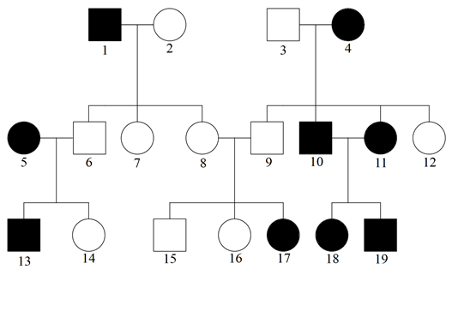

- sex-linked
- co-dominant
- autosomal recessive
- autosomal dominant

- Which of the following is NOT a function of the liver?

- formation of glycogen
- formation of urea
- production of bile
- secretion of digestive enzymes

- Refer to the setup of two beakers shown in the Fig. 1 below. Two visking tubes were filled with the same volume of liquid A. One was placed into a beaker filled with liquid B whilst the other tube was placed into a beaker filled with liquid C.

If liquids A, B and C are sucrose solutions of different concentrations, determine which of the following statements is false.

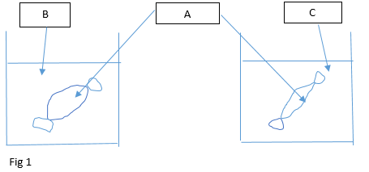

- Liquid B has a lower sucrose concentration than liquids A and C.
- Liquid A has a higher sucrose concentration than liquid B but a lower concentration than Liquid C.
- Liquid C has the highest sucrose concentration among Liquids A, B and C.
- Liquid A has a lower sucrose concentration than Liquid B but a higher concentration than Liquid C.

- Many enzymes require the presence of certain ions before they will catalyze a reaction. Such substances known as______________ change the shape of the active site so that enzyme can combine with the substrate. Without these, enzymes cannot function.

- co-factors
- vitamins
- inhibitors
- lysozymes

- Refer to the diagram Fig 2 below which shows part of the human digestive system.
Identify the two structures that produce substances involved in fat digestion.

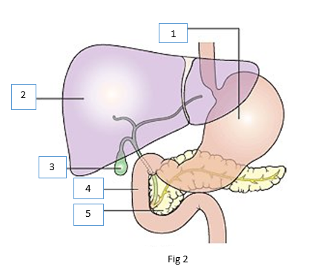

- 1 and 2
- 2 and 3
- 3 and 4
- 2 and 5

- Which of the following does not use ATP (adenosine triphosphate)?

- Diffusion of oxygen across the alveolar surface
- maintenance of a constant body temperature
- passage of nerve impulses
- active transport of glucose into the villi

- Which of the following describe changes that occurs when a person inhales?

Diaphragm External intercostal muscles
- contracts contract
- contracts no change
- contracts relax
- relaxes contract

- Research shows 68% decrease of spina bifida rates and other neural tube defects in Aboriginal children since mandatory fortification of wheat-flour for bread was introduced in Australia in 2009. Which vitamin was supplemented in the bread?
(Newspaper source: The West Australian 17 December 2015, page 62).

- ascorbic acid
- thiamine
- folate
- niacin

- About 170 litres of fluid are filtered by the kidneys every day. Only 1.5 litres are excreted in the urine. What happens to the remaining 168.5 litres?

- It is lost in the perspiration as sweat.
- It becomes tissue fluid.
- It is stored in the urinary bladder.
- It is reabsorbed into the blood.

- Which of the following correctly identifies examples where different types of cartilage are located in the human body?

 | Hyaline cartilage | Elastic cartilage | Fibrocartilage
(a) | bronchi | intervertebral discs | larynx
(b) | intervertebral discs | bronchi | external ear
(c) | trachea | external ear | intervertebral discs
(d) | external ear | trachea | bronchi

- When a soldier salutes to his superior, the movement of his lower arm may be described as

- extension
- flexion
- bending
- straightening

- There are different types of birth control methods – hormonal, surgical or mechanical.
Identify the correct match for each method.

 | hormonal | mechanical | surgical
(a) | condom | spermicide | intrauterine device
(b) | emergency contraceptive pill | intrauterine device | vasectomy
(c) | vasectomy | diaphragm | tubal ligation
(d) | intrauterine device | condom | Emergency contraceptive pill

Refer to the following diagram to answer Question 14 and 15.

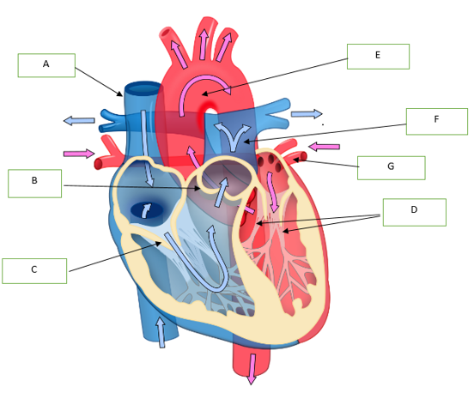

- The parts of the heart labelled B and D are _______ and ________ respectively.

- semi-lunar valves, chordae tendineae
- chordae tendineae, semi-lunar valves
- aorta, left ventricle
- septum valves, atrioventricular valves

- Oxygenated blood flows into and out of the heart is described by the pathway

- A & B → right atrium → right ventricle → F
- A & B → left atrium → left ventricle → F
- G → left atrium → left ventricle → E
- G → right atrium → right ventricle → E

- Which of the following sexually transmitted diseases can be easily treated with antibiotics?
- herpes simplex
- genital warts
- chlamydia trachomatis
- scabies

- The following diagram shows the changes in the thickness of the uterine lining of a woman during a menstrual cycle. On what day would the woman be most fertile?

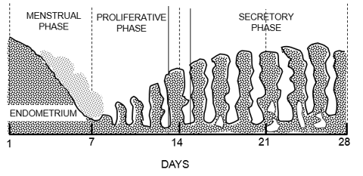
- Day 7
- Day 14
- Day 21
- Day 28

- The diagram below shows the arrangement of blood vessels in the uterus wall and placenta of a pregnant woman. As blood flows from 1 to 2, the level of _____________ will increase.

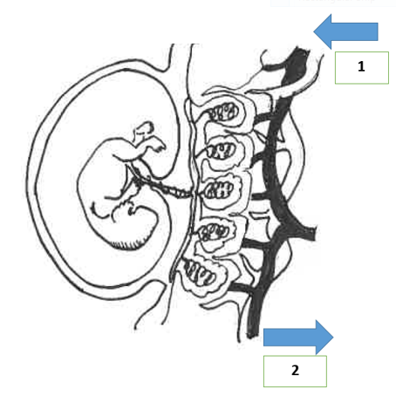
- carbon dioxide
- glucose
- amino acids
- oxygen

- At which phase of cell division can we observe the following?
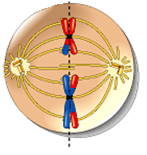

- Metaphase 1 of meiosis
- Metaphase 2 of meiosis
- Anaphase 1 of mitosis
- Anaphase 2 of meiosis

- The dominant hormone controlling the secretory phase of the menstrual cycle is

- progesterone.
- follicle-stimulating hormone.
- luteinizing hormone.
- human chorionic gonadotropin (HCG).

- The diagram shows a fetus at a stage of pregnancy where the hormonal system plays an important role in initiating it. Which of the following correctly indicate the main hormone(s) at work?

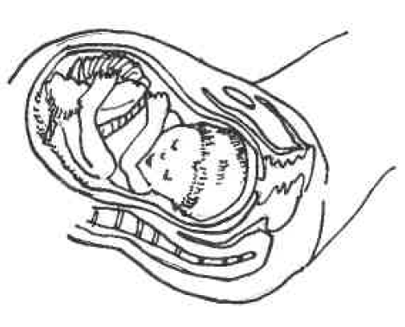
- oestrogen and oxytocin
- progesterone and oestrogen
- oestrogen
- oxytocin

Refer to the following table for Question 22 and 23.

The table below shows the amino acid and the corresponding mRNA codons.

mRNA codons for 6 amino acids

Amino acid | Codon
alanine | GCA
leucine | UUG
methionine | AUG
arginine | CGU
histidine | CAU
tyrosine | UAC

- What is the base sequence on a DNA molecule that will allow the amino acid arginine to be incorporated into the polypeptide chain?

- GCT
- CGU
- CGA
- GCA

- Transfer RNA has a role in the translation of polypeptides. What amino acid would be carried to the ribosome by transfer RNA with the anti-codon CGU?

- arginine
- alanine
- histidine
- methionine

- Research with embryonic stem cells presents ethical issues because one needs to consider

- the advantages and disadvantages of using the embryonic stem cells
- how society can fully benefit from the use of embryonic stem cells
- the moral status of the human embryo
- the potential commercial benefit and sources of funding for embryo research

- Colostrum are important for the health of a very new baby mainly because it contains

- nutrients
- amino acids
- vitamins
- antibodies

Please refer to the graph as follows to answer Question 26.

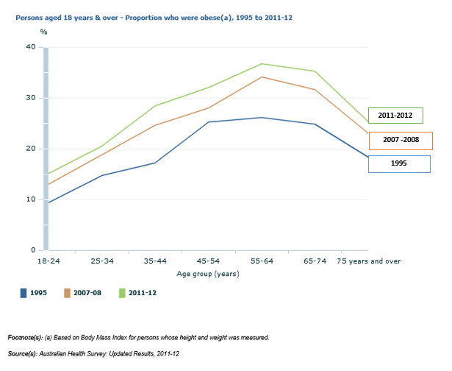

- What is the most likely conclusion that can be drawn from this graph?

- There is a positive correlation between age and the percentage of persons who are obese.
- Older persons develop higher body mass index and are at greater risk of obesity.
- The increase in the proportion of people who are overweight or obese is being driven by a general increase in weight and body mass index over time.
- It is not possible to draw any conclusion.

27. An example of a gliding joint is the

- inter-carpal joint
- radiocarpal joint
- intervertebral joint
- phalangeal joint

28. Peristalsis moves food material

- in the stomach and small intestines only.
- in the stomach and intestines only
- from the pharynx to the anal canal
- in the oesophagus and stomach only.

29. A cell in the germinal epithelium of the seminiferous tubules has 12 units of DNA. Which of the following indicate the correct number of units of DNA in a primary spermatocyte, a secondary spermatocyte and a spermatid?

 | a primary spermatocyte | a secondary spermatocyte | a spermatid
(a) | 12 | 6 | 6
(b) | 24 | 12 | 6
(c) | 12 | 6 | 3
(d) | 12 | 12 | 12

30. In the placenta, the mother’s blood and the fetal blood flows in opposite directions.
This is important because this counter current flow will

- increase surface area for nutrient absorption
- increase the rate of waste removal
- build up concentration gradient all the way along the capillary to facilitate diffusion
- balance the input of nutrients and output of waste products.

End of Section One
SUMMARY OF MCQ ANSWERS

1 | B | 11 | C | 21 | A
2 | C | 12 | B | 22 | D
3 | D | 13 | B | 23 | B
4 | D | 14 | A | 24 | C
5 | A | 15 | C | 25 | D
6 | D | 16 | C | 26 | C
7 | A | 17 | B | 27 | A
8 | A | 18 | A | 28 | C
9 | C | 19 | B | 29 | A
10 | D | 20 | A | 30 | C

Section Two: Short answer 50% (100 Marks)

This section has ten (10) questions. Answer all questions. Write your answers in the spaces provided.

Spare pages are included at the end of this booklet. They can be used for planning your responses and/or as additional space if required to continue an answer.
  - Planning: If you use the spare pages for planning, indicate this clearly at the top of the page.
  - Continuing an answer: If you need to use the space to continue an answer, indicate in the original answer space where the answer is continued, i.e. give the page number. Fill in the number of the question(s) that you are continuing to answer at the top of the page.

Suggested working time: 100 minutes.

Question 31 (8 marks)

The following histology slide shows a picture of a type of Tissue A.

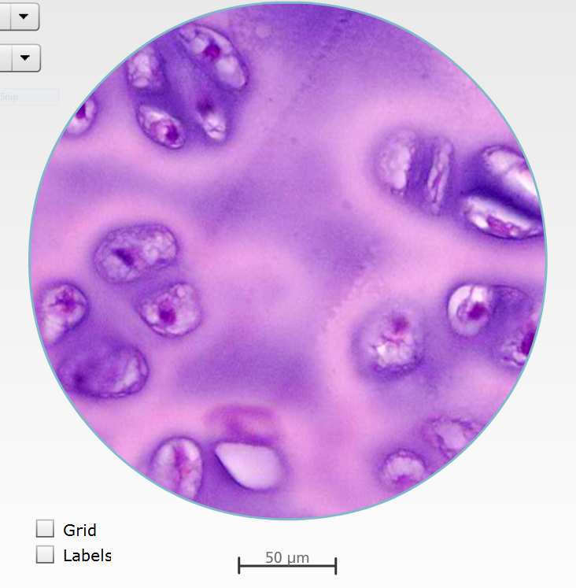

- To which of the four categories of tissue type does Tissue A belong? (1 mark)
Connective tissue

- Name one characteristic of Tissue A. (1 mark)

The cells are not close together / cells are separated from each other by large amounts of material that is not made of cells – the matrix
(Any 1, 1 mark)

- Name one location Tissue A is found in the human body. (1 mark)
Surface of bones at joints, trachea, bronchi, nose, larynx and outer ear
(this is hyaline cartilage)

- What is the function of Tissue A? (1 mark)
This provides structural support for the body and helps to hold all body parts together, yet with some flexibility.

The following histology slide shows a picture of type of Tissue B.

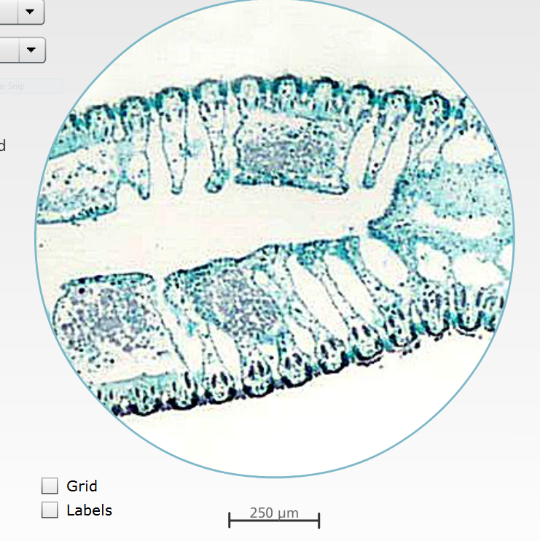

(b)

- How is Tissue B different from Tissue A? (1 mark)
The column-shaped cells fit very closely together to provide a smooth surface - cells have little or no matrix between them.

- What does this tell us about the function of Tissue B? (1 mark)
It is a covering / lining tissue.

- Name the Tissue B. (1 mark)
Epithelial tissue

- Identify one location of Tissue B. (1 mark)
The outer layer of the skin, lines inside of the organs such as the heart, stomach and intestines (any one)

Question 32 (8 marks)

- Three different sized bromothymol blue agar cubes were soaked in an acid solution for several hours.

Please note: Bromothymol blue will turn yellow when exposed to acid

Cube A - 1 cm by 1 cm by 1 cm
Cube B – 2 cm by 2 cm by 2 cm
Cube C – 3 cm by 3 cm by 3 cm

- Which cube would turn yellow first? (1 mark)
Cube A

- Give a reason for your prediction. (2 marks)
Cube A – has the greatest surface area to volume ratio.
Work out
Vol = 1 cm³ SA = 6 x (1 x 1) = 6 cm²
SA/Vol Ratio = 6
(cf to Cube B which is 24/8 = 3 and Cube C which is 54/27 = 2)

- An athlete suffering from severe dehydration was given large volumes of saline solution (0.9% of sodium chloride). Why was saline solution given instead of plain water? (1 mark)

Body fluids would be dilute and the water would be excreted, if only plain water introduced into the blood/ there is a risk in that cells would swell and possibly burst as the water diffused across the membrane. (1)

- Glucose and amino acids can be absorbed through the small intestine wall into the blood by carrier-mediated transport.

- Identify the two carrier-mediated transport processes. (2 marks)
Facilitated diffusion [1] and active transport [1]

- What is the difference between each process given in (i)? (2 marks)

Active transport is an active process / requires energy/ ATP (adenosine triphosphate) [1]

Facilitated diffusion is a passive process that moves substances along a concentration gradient /does not require energy/ does not require ATP. [1]

Question 33 (12 marks)

- How is the composition of blood different from lymph? (1 mark)
Blood contains RBC’s while lymph does not contain RBCs (1)
Blood contains platelets while lymph does not contain platelets (1)]
Blood contains plasma proteins while lymph does not contain plasma proteins (1)
Any 1, 1 mark, but must compare a difference.

- State the antigens or antibodies in the appropriate blood group. (4 marks)
(1 mark for each correct entry)
Blood Group | Antigens on red blood cells | Antibodies in plasma
A | Antigen A | Anti-B
B | Antigen B | Anti-A
AB | Antigen A and Antigen B | Neither anti-A nor anti-B
O | Neither antigen A nor antigen B | Both anti-A and anti-B

- Why is it important to match the blood groups of the donor and recipient during blood transfusions? Give an example. (2 marks)

- Mixing of blood types that are incompatible cause red blood cells to clump or agglutinate and disintegrate.
Eg. A donor and B recipient.

i) What makes a cardiac cycle? (1 mark)

The sequence of events that occurs in one complete beat of the heart. It consists of the pumping phase of systole and a filling phase called diastole that occurs in one complete beat of the heart.

ii) At the peak of a triathlon, James’ cardiac output was monitored to be 17.5
L/min. Define cardiac output and explain what the numerical value stands for.
(2 marks)
The volume of blood expelled from the heart in one minute.

Cardiac output (mL/min) = Stroke volume (mL) x heart rate (beats/min)
That is to say, the volume of blood expelled from the heart in one min -
is 17.5 Litres per minute.

- Outline two changes that occur to the foetal circulation after birth. (2 marks)
- The foramen ovale closes.
- Blood flow through ductus arteriosus (lung bypass) decreases and becomes reduced to a fibrous tissue so blood returns to the heart from the lungs via the pulmonary vein.
- Blood flow through ductus venosus (liver bypass) decreases so blood flows through the liver and returns to the heart via the inferior vena cava. (any 2 of the above)

Question 34 (8 marks)

Refer to the diagram below to answer Question 34.

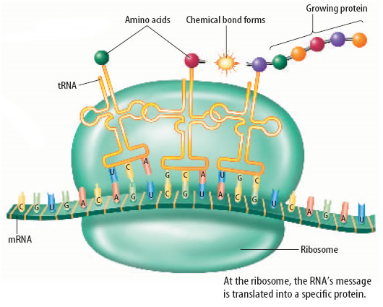
Process Q

- Identify the process Q as depicted in the diagram above. (1 mark)
Translation

- Outline the steps involved in process Q to form the end-product. (4 marks)
- Ribosome moves along the mRNA three bases (codon) at a time.
- tRNA (transfer RNA) is a small molecule that brings amino acid to the ribosome.
- It has a set of 3 bases (in its loop) called the anticodon which are complementary to the codon of the mRNA.
- The amino acids carried by the tRNA are joined together by peptide bond to form proteins.

- Give three examples of the end products and their role in cellular functions. (3 marks)

- Haemoglobin - increases oxygen carrying in red blood cells)
- Hormones -regulating cell functions
- Enzymes – speed up rate of reactions eg. respiration
- Immunoglobulins – act as antibodies in fighting foreign matter
- Actin and myosin – from proteins involved in muscle contraction
(any 3, 1 mark each but need both name and function)

Question 35 (10 marks)

- A student wrote in an exam ` Homologous chromosomes are the same as each other because they have the same genes’. Explain what is wrong with this statement. (2 marks)
Homologous chromosomes have the same genes, but they may have different
alleles from each other (1). Therefore, they are not genetically identical.(1)

- A pair of chromatids form the chromosome. Do you agree or disagree and why.
(2 marks)
Disagree.

- Most of the time chromosomes are single stranded, loosely coiled in the form known as chromatin.
- When sister chromatids separate during mitosis, the individual chromatids are still considered as chromosomes.

- State the purpose of the following types of cell division. (2 marks)

- mitosis – cell division for growth and repair

- meiosis – cell division for producing gametes (eggs and sperms)

- What are the differences between the cell divisions involved in spermatogenesis and oogenesis? (4 marks)

- In spermatogenesis, the nucleus of the germ cell divide twice (1) to produce four similar sized gametes (sperm cells). (1)
- In oogenesis, the two divisions are not equal (1) and only one of the four nuclear (and most of the cytoplasm) produce one egg cell and three polar bodies. (1)

The following will NOT be accepted because the question is asked on `cell divisions’.
- Spermatogenesis occurs all the time in a man after the age of puberty.
- All the stages up to the first division of meiosis occur before a woman is born.

Question 36 (8 marks)

- What is meant by epigenetics? (1 mark)

Epigenetics is defined as mitotically heritable changes in gene expression that occur without change in DNA code (genome).

For part (b) – (d), refer to the diagram below.

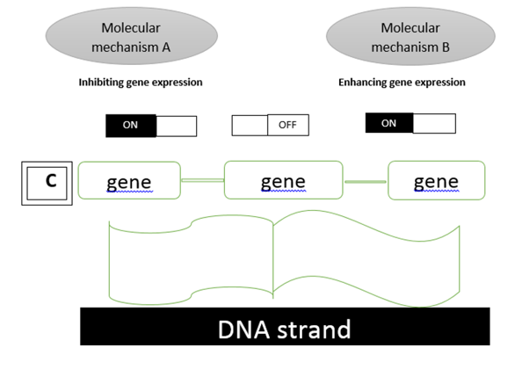
- Identify the molecular mechanisms as follows: (2 marks)

- A – DNA methylation

- B – Histone modification

- C interacts with DNA and changes the level of gene expression in a cell. (1 mark)

C is known as the epigenome.[1]

- Using your understanding of epigenetics, explain why identical twins are preferred subjects for research than fraternal twins and that twins are chosen over a large span of ages. (2 marks)

Identical twins share identical genotype/ genome so any difference may be attributed to epigenetic factors. [1] A large span of ages are chosen for subject to study the cumulative effect of epigenetic factors and more time given in terms of exposure to environmental effects. [1]

- How is epigenetic inheritance different from genetic inheritance? (2 marks)
Genetic inheritance happens through the DNA code that passes from the parent to offspring while in epigenetic inheritance, epigenetic tags can be passed down to future generations without any change in the DNA code [1]. This epigenetic tags are influenced by environmental factors. [1]

Question 37 (10 marks)

Please refer to the diagram to answer Question 37.
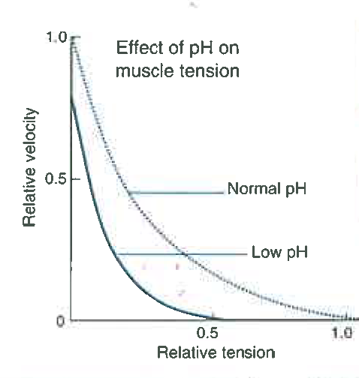

- What type of respiration is taking place when oxygen demands exceed supply as shown in the diagram? (1 mark)
Anaerobic

- What happens in the muscle that causes a fall in the tissue pH? (1 mark)
Lactic acid accumulation

- Why does this lead to muscle fatigue? (1 mark)
Low pH leads to inhibition of key enzymes involved in ATP production; less energy produced so muscle fatigue sets in.

- State the relationship between tissue pH and muscle tension as indicated in the graph. (1 mark)
As the tissue pH lowers, the rate of drop in muscular tension increases.

- Explain why the reasons for fatigue in a marathon runner is different from a 100 m sprinter. (1 mark)
In a long distance race, such as the marathon, ATP continues to be produced aerobically until all energy supplies are exhausted. In the case of the 100 m sprint, ATP is produced anaerobically until the oxygen debt has been repaid.

- Using diagram(s), outline how the sliding filament model can be used to explain muscle contraction. (5 marks)

Make use of an annotated diagram | Marks
- Energy in the form of ATP needed for this  - Actin are thin filaments  & Myosin are thick filaments  - The actin filaments slide over the myosin filaments  - Z lines/ anchor points for actin to become closer together  - Sarcomere shortens  and the filaments do not change in length  - Calcium is released from sarcoplasmic reticulum  - Calcium binds to actin filament altering its shape to reveal myosin binding site  - A cross bridge forms where myosin heads connect to the filaments and movement occurs when bridge pulls them over one another  - I band when only actin occurs shortens | 1 - 5

Question 38 (10 marks)
The following diagram shows the respiratory system in a human body.
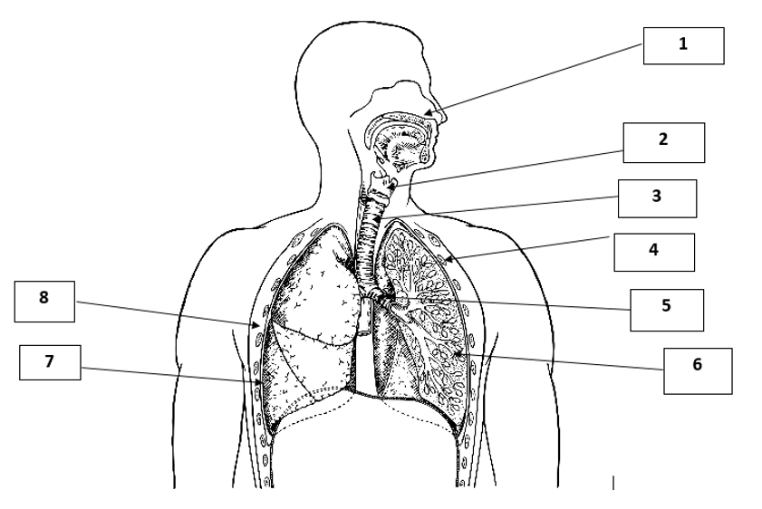
- Label the numbered structures 2,5, 6 and 7. (4 marks)

2 | larynx
5 | bronchus
6 | alveoli
7 | pleural membranes

- Select two structures of the respiratory system and state how each of this structure is suited gaseous exchange. (4 marks)

Either two of the following listed.
(1 mark for stating the structure and 1 mark for the function)

Structure | How it is suited to its function
Nasal passage | It is lined with hair to trap dust and remove tiny foreign particles/ warms air to enhance diffusion of gases/ moistens air to enhance diffusion of gases
Trachea | It has C-shaped rings of cartilage to support the trachea in open position when the thoracic pressure falls/ along the trachea, it has lining of ciliated epithelium with goblet cells which secrete mucus to trap and remove pathogens and particles of dust and smoke.
Bronchus | It has cartilaginous rings to prevent collapse during inspiration.  Smooth muscle in bronchioles allows the diameter to be controlled.  Branching effect of bronchioles allows for more air to be transported in a given time.
Alveolus | This is the actual site of gas exchange between air and blood.  Alveolar-capillary (respiratory) membrane consists of:  - Alveolar wall – one layer of squamous epithelium and alveolar macrophages  - Epithelium and capillary membrane  - Endothelium of capillary wall  These layers form a very thin section of only 0.5 um in thickness.  It is thin, moist and of great surface area (about 70 m square) to allow diffusion of oxygen and carbon dioxide to take place very efficiently.  - Elastic fibres in alveolus permit optimum extension during inspiration. This feature is affected in smokers (emphysema).
Alveolar capillaries | Alveolar capillaries adjacent to the alveolus (connected to pulmonary artery and vein) are the site of oxygen and carbon dioxide transfer between the air in the alveolus (air sac) and the circulating blood.
Lungs | The lung is an excellent gas exchange surface;  - Diffusion distance is short/  - Enormous surface area so more gas molecules can cross in a given time  - Efficient ventilation system  - Extensive circulation  - Keep large diffusion gradients in the right direction.  As a structure, the lungs are passive, elastic structures which are able to follow muscular movements in pulmonary ventilation.
Stretch receptors | Provide sensory input which initiates reflex control of the breathing cycle.

- Explain how a person with a collapsed lung can function fairly normally. (2 marks)

The internal surface area of the lungs greatly exceeds that required for gas exchange for normal activity. [1] The surface area of one lung is sufficient but will struggle with strenuous activity [1] (where the increased demand for oxygen exists.)

Question 39 (8 marks)

The ability to discriminate between the colours red and green is controlled by a gene located in the X chromosome. Individuals who are unable to distinguish between the two colours possess the recessive allele of this gene.

- Why would colour blindness be more common in males than in females? (1 mark)

The colour blindness gene is located in the X-chromosome (but not the Y). Since the males only carry one X chromosome, the chances of the gene expressing the recessive allele is higher.

- An unaffected woman who carries a recessive allele is considered to be heterozygous. What term can be used to describe a colour blind man? (1 mark)
hemizygous

- Describe a scenario where a couple produce daughters who all have normal vision and sons who are all colour blind. Use a punnett square to illustrate this, describing the genotypes of both parents and their children. (3 marks)

(2 marks)
 | Xb | Xb
XB | XBXb | XBXb
Y | XbY | XbY

Parents:
Genotypes – XbXb and XBY (1 mark)

Children:
Genotypes: males with be XbY and females will be XBXb (could have more than one possible answer here.)

- (i) Explain why we inherit nuclear DNA from both our parents but mitochondrial DNA from our mothers. (1 mark)

Both human eggs and sperms have mitochondria but the eggs has many hundreds of mitochondria DNA compared to the 100 in sperm which is adequate to provide the energy for the sperm to swim to the egg. After the sperm has penetrated the egg at fertilisation, the mitDNA in the body section of the sperm (thus not penetrating the egg) are rapidly destroyed. Hence, our nuclear DNA comes from the nucleus of the egg and sperm but the mitDNA only comes from the egg.

(ii)For what reason would study of mitochondrial DNA be extremely useful? And why? (2 marks)
As mitochondrial DNA is only inherited from the maternal line (1) it would be useful for genetics to study ancestral lineage (1), track human migrations,(1) population genetics (1), mutations, (1) evolutionary history (1), etc.

Question 40 (18 marks)

At 48 medical centres in Western Australia, 2008 otherwise healthy, postmenopausal women with bone mass density (BMD) lower than the premenopausal adult mean were randomly assigned to receive the oral drug alenodronate 10 mg (n = 1020) or a placebo (n = 998) once daily for 15 months.

All patients also received 500 mg of elemental calcium daily. Baseline characteristics of patients in the two treatment groups were similar. Every three months, change in BMD was measured and incidences of non-vertebral fractures were recorded.

This randomised, double blind, placebo-controlled experiment evaluated the effects of the alenodronate on bone mass density (BMD) in the state population of post-menopausal women with observed low bone mass.

Table of Results

Time (months) | Bone Mass Density Change %
 | Placebo | Experimental Drug
Beginning of experiment | 0 | 0
After 3 months | - 1.1 | 0.5
After 6 months | - 1.5 | 1.5
After 9 months | - 2.3 | 2.2
After 12 months | - 2.5 | 3.1
After 15 months | - 2.9 | 4.4

Title (1) correctly labelled axes with title and units (1) , accurate plotting of graphs (1), appropriate representation – line graph (1) and key (1)

(a)Graph the results from the table on the grid provided below. (6 marks)

Time / no of months

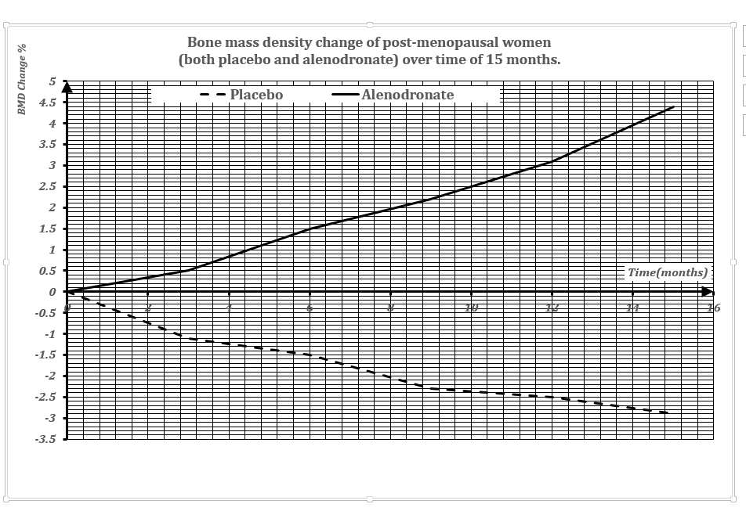

(b)What is a double blind placebo-controlled experiment? (2 marks)
` `Double blind’ means neither the researcher nor the participant know who is receiving the treatment or the placebo’ (1)
`Placebo-controlled’ means `the control group’ is taking an inactive substance that looks like the experimental drug (1)

(c) State the hypothesis of this experiment. (1 mark)
Daily oral intake of alenodronate increases the bone mass density of post-menopausal woman (over the period of 15 months – optional).

- From the information given, what are some variables that are controlled in this experiment? (1 mark)
frequency of intake, general health condition with observed low bone mass, controlled amount of calcium intake (any 1, 1 mark)

- What steps were taken to ensure the reliability of the data collected? (1 mark)
Experiment with a large number of subjects /randomised mode of operation/ involves a localised group of post-menopausal women (Any 1, 1 mark)

- What is the conclusion of this experiment? (1 mark)
Alenodronate appears to increase bone mass density of post-menopausal women (hence reducing the risk of non-vertebral fractures – students may make an inference here).

- Suggest ways of improving the design of this experiment. (1 mark)
Ensuring some form of consistency in the daily diet of subjects, monitoring the level of exercise subjects are involved daily (sedentary or active lifestyle), etc. (not increase in numbers of participants as numbers are already quite high).

- Why were postmenopausal women considered as subjects of this experiment?
(1 mark)
Menopause brings about a drop in oestrogen which brings about gradual decrease in bone density as the bones loses calcium and other minerals. With this pronounced effect and vulnerability, postmenopausal women are considered significant subjects for such experiment.

- Name two bone conditions that affect ageing / elderly population and outline the difference between these conditions. (4 marks)

Osteoarthritis (1) – gradual change in joints due to joint cartilage deterioration and stiffness, formation of spurs and restricted movement (1)
Osteoporosis – (1) loss of bone mass / density leading to high risks of fractures (1)

End of Section Two

Section Three: Extended answer 20% (40 Marks)

This section contains three (3) questions. You must answer two (2) questions. Make sure you clearly indicate which question you are answering and write your answers in the space provided.

Spare pages are included at the end of this booklet. They can be used for planning your responses and/or as additional space if required to continue an answer.
  - Planning: If you use the spare pages for planning, indicate this clearly at the top of the page.
  - Continuing an answer: If you need to use more space to continue an answer, indicate in the original answer space where the answer is continued, i.e. give the page number. Write the number of the question(s) that you are continuing to answer at the top of the additional space page.

Responses could include clearly labeled diagrams with explanatory notes; lists of points with linking sentences; clearly labeled tables and graphs; and annotated flow diagrams with introductory notes.

Suggested working time: 40 minutes.

Question 41 (20 marks)

- Describe how genetic variation occurs during the process of meiosis and indicate how non-disjunction can occur. Include in your answer a description of the outcome of non-disjunction (4 marks)

Correct responses – crossing over and independent assortment (random fertilisation is not accepted)
- Non-disjunction can occur during Meiosis 1 when homologous chromosomes pair and separate, and sometimes one or more pairs of the chromosome may fail to separate when the cell divides. (1) or
- Non-disjunction can also occur during Meiosis 2 when one or more of the chromatids may fail to separate. (1)
Answer – need to state how it occurs in the correctly specified phase for 1 mark

- This lead to one of the daughter cells getting an extra chromosome and the other daughter cell lacking that chromosome. (1) or
- This changes in resultant chromosomal number can cause severe and distinctive birth defects and sometimes miscarriage early in pregnancy. (1)

- Compare and contrast two named types of chromosomal analysis techniques that can be performed on a fetus to detect the genetic condition caused by non-disjunction. Identify the risks involved, state the limitations of each technique and specify other disorders that can also be detected through these techniques.
(12 marks)
Chromosomal analysis techniques

Amniocentesis | -Removal of amniotic fluid (16th-20th week pregnancy) from amniotic sac – about 10 – 20 ml  -Floating in fluid are living cells of fetus  -Detect chromosomal abnormalities (Down Syndrome, neural tube defects, genetic disorders such as Tay Sachs and muscular dystrophy  -Other disorder – identify biochemical defects a  -Risk- infection, miscarriage or damage to baby  -Limitation – certain genetic diseases not all [6]
Chorionic villus sampling | -Obtain fetal cells from chorion and examine same way as amniocentesis  - Test take place at 9 – 19 weeks of pregnancy  - Quick procedure  -Other disorders –genetic disorders and biochemical abnormalities  -Risk – miscarriage  -Limitation – cannot pick up spina bifida [6]
Fetal blood sampling | -obtain fetal blood samples from placenta  - directly obtainable  - quick procedure and diagnosed on the day/early treatment  - reduced risk  - other disorders – include foetal haemolytic abnormalities, intrauterine infection, growth retardation, birth defects & metabolic disorders.  - minimal limitation [6]
For each type,
3 marks for the technique
1 mark for specifying other disorder
1 mark for risks involved
1 mark for limitation

- Raise points on different procedure, timing and duration of diagnosis, different types of risks and range of disorders detected (any 2 points raised)

- Discuss two ethical considerations in the use of assisted reproductive technologies.
(4 marks)

- Identify the assisted reproductive technologies – IVF, GIFT or ICSI ( 2 marks )
- Ethical issues from how the extra embryos are being utilised (2 marks for any 2 ethical issue mentioned_.
- Ethical issues on how embryos are used for research purpose
- Ethical issues on the donation and sale of embryos (sanctity of life); commodification of life
- Ethical issues on autonomy, value of life and identity of the unborn

Question 42 (20 marks)

The human body performs a number of important functions on the molecular as well as systemic level to ensure waste products are effectively removed from the body.

- Describe how carbon dioxide is transported away from the body cells to the exterior. (10 marks)

Systemic Level | Respiratory and circulatory system (1)  - Structures the carbon dioxide passes on exhalation (1)  - Role of the blood in transporting waste from body cells to lungs (1)  Total – [3]
Cellular  Level | Gas exchange at the alveolar surface / capillary/ lung surface (1)  - Blood capillaries surrounding the alveoli (1)  - Exchange of carbon dioxide out – diffusion (1)  - Due to concentration gradient (alveolus) and (Lungs) (1)  - Carbon dioxide carried in the blood via a number of ways  - Combines with haemoglogin to form carbaminohaemoglobin (1)  - Remainder about 70% in the plasma as bi-carbonate ions (1)  - Chemical equation given as follows: (1) Total –[7]  - 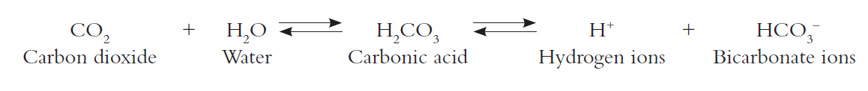

Some use of annotated diagrams will be accepted.
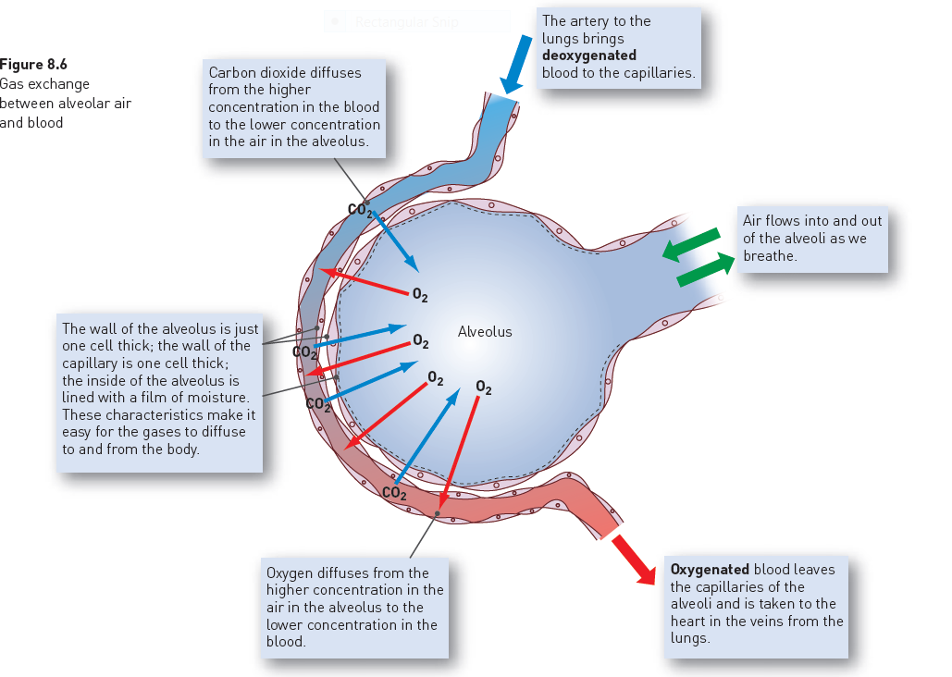

- Using an annotated diagram, describe how water needed by the body is reabsorbed; and how named metabolic (organic) wastes and excess water are transported from the body cells to be discharged to the exterior. (10 marks)

Excess Water | Urine formation – nephrons in kidney –bladder (1)  Passive reabsorption of water by diffusion in PCT and Loop of Henle (1)  Obligatory diffusion of water through loop of Henle  -active reabsorption of water in the DCT and CD depending on body water’s needs – 99% water re-absorbed and remaining 1% released (1)  - Water not reabsorbed are drained from collecting duct into renal pelvis and collected as urine drained into ureter, bladder (stored) and discharged to exterior (via the urethra) (1)  Digestive System (1)  - Large intestine and stomach absorbs water and vitamins [5]
Metabolic Wastes | Tubular secretion (1)– either active or passive (1)  Secreted organic wastes (eg creatinine, urea) (1)  into the filtrate from the blood (1) [5]  Annotated Diagram to support the answer [1]

Question 43 (20 marks)

- Describe the processes of diffusion and vesicular transport that result in transport of materials in and out of cells. (6 marks)

Diffusion | Moves substances along concentration gradient difference/ from high to low concentration (1)  Passive/ No energy or ATP required. (1)
Vesicular transport | Materials are moved in membrane-bound sacs (1)  Active, needs ATP (1)  Endocytosis - Pinocytosis – taking liquids into cells (1)  Phagocytosis – taking solid particles into cells (1) or  Exocytosis – contents of vesicles from inside cell is transport outside cell (extra cellular fluid) (1)

- Describe the changes involved from the formation of the zygote to its implantation in the uterine wall of the mother. You may use diagrams to support your answer.
(9 marks)
Zygote formation to implantation | - - Zygote forms in the Fallopian tube when sperm fertilizes the egg (1)  Undergoes mitosis (1)  Becomes a morula/ a solid ball of cells (1)  - Becomes a blastocyst (hollow ball of cells surround a fluid-filled cavity with an inner cell mass (30 cells) – embryoblast (1)  Enters into the uterus where it remains for 2 – 3 days (1)  Forms an inner cell mass (1)  Surrounded by amnion and chorion (1)  attached to uterine wall firmly to gain nourishment – implantation (1)  Inner cell mass forms three embryonic layers/ develops into embryo composed of stem cells (1)  [9]

(c)Identify some environmental factors that can affect the development of the fetus.
Use an example to illustrate how the environmental factor you have stated
can affect the development of the fetus. (5 marks)

Environmental Factors | Second-hand smoke  Mother’s diet (including alcohol, drugs and medicinal products)  Viral infections  Lead and other pollutants (any 3)
Example (s) | Ingestion of too much alcohol can cause fetal alcohol syndrome  Lead accumulation can lead to the damage of the developing central nervous system. (2)

END OF SECTION THREE

References

Section One

Multiple choice question 13 and 14

Structure of the heart

https://upload.wikimedia.org/wikipedia/commons/thumb/6/67/Heart_diagram_blood_flow_en.svg/913px-Heart_diagram_blood_flow_en.svg.png

This file is licensed under the Creative Commons Attribution-Share Alike 3.0 Unported license

Multiple choice question 17

Menstrual cycle diagram adapted from: Harrison, J. (n.d.). Unit 2B Hormonal control of reproductive system. Slide no.9. Western Australia: Ecopress Publications.

Multiple choice question 18

Drawing provided. Courtesy of S Yap.

Multiple choice question 21

Drawing provided. Courtesy of S Yap.

Multiple choice question 26

Graph of percentage of persons 18 years & over from 1995 to 2011-2012 – Retrieved on 12 March 2016 from the Australian Bureau of Statistics 4338.0 – Profiles of Health, Australia 2011-13 released on 7 June 2013 Issue from
http://www.abs.gov.au/ausstats/abs@.nsf/Lookup/by%20Subject/4338.0~2011-13~Main%20Features~Overweight%20and%20obesity~10007

Section Two
Question 31
Histology Slide A - http://spice.wa.edu.au
Histology Slide B - http://spice.wa.edu.au

Question 34
Translation in Protein Synthesis - http://www.biologyteksbylauryncarter.weebly.com/protein-synthesis.html

Question 36
Diagram provided. Courtesy of S Yap.

Question 37
Graph showing the effect of pH on muscle tension adapted from: Biology Modular Workbook Series. 2nd Ed. (2013) Anatomy and Physiology. New Zealand: Biozone International Ltd. Page 79.

Question 38
Respiratory system – adapted from [Diagram]. Retrieved March, 10, 2016. www.shutterstock.com/pic-89315977

